**Introduction**

**Objective of the project**

Use any open source software to recover deleted files and directories, images in last 3 months from your system. Also generate the report for the same.

**Description of the project :-**

A script is written with all the commands to recover deleted files and directory.

**Scope of the project :-**

Once the script is written all the commands are executed one by one. This made it very easy to use.

**System Description:-**

Target system description :- Used ubuntu for the open source software.

**Analysis Report**

3.1 System snapshots and full analysis report

TestDisk is a free data recovery software designed to help recover lost partitions and/or make non-booting disks bootable again when these symptoms are caused by faulty software, certain types of viruses, or human error. It can also be used to repair some filesystem errors.

First to check it is installed or not. If not then installing it.

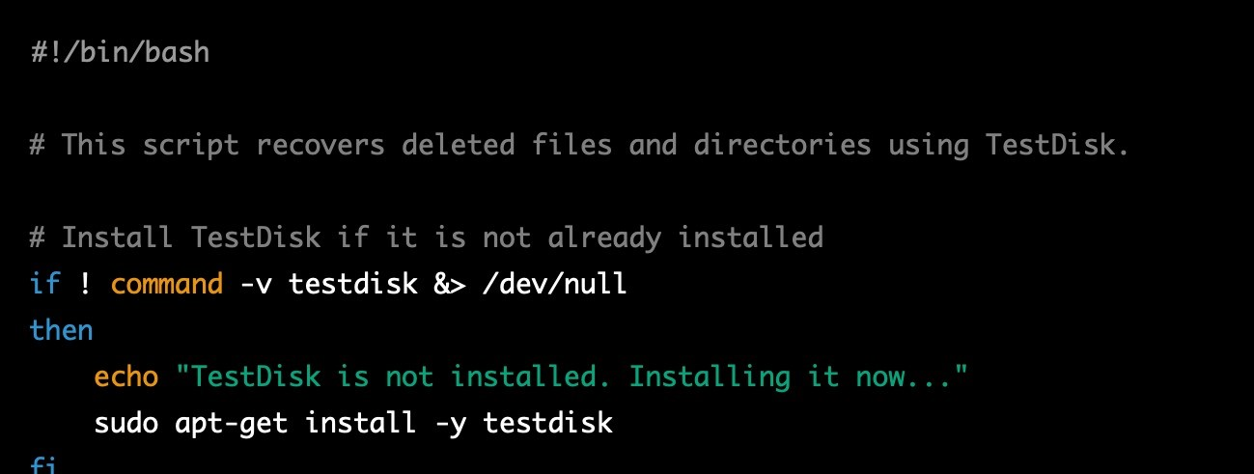

Defining the target directory for the recovered files and directories. 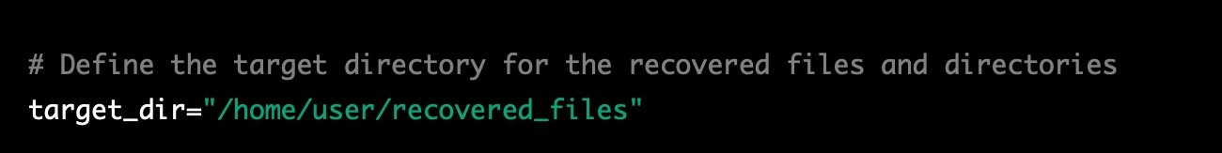

Now the recovering process is done with TestDisk .

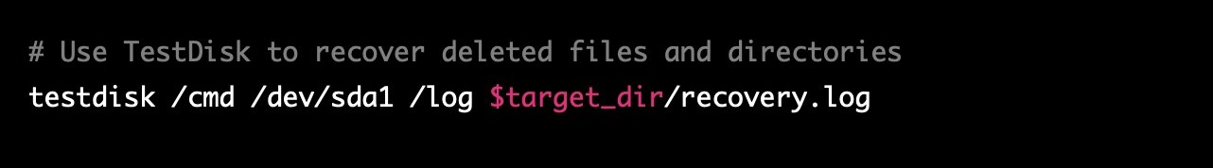



Generating report to get the recovered files.



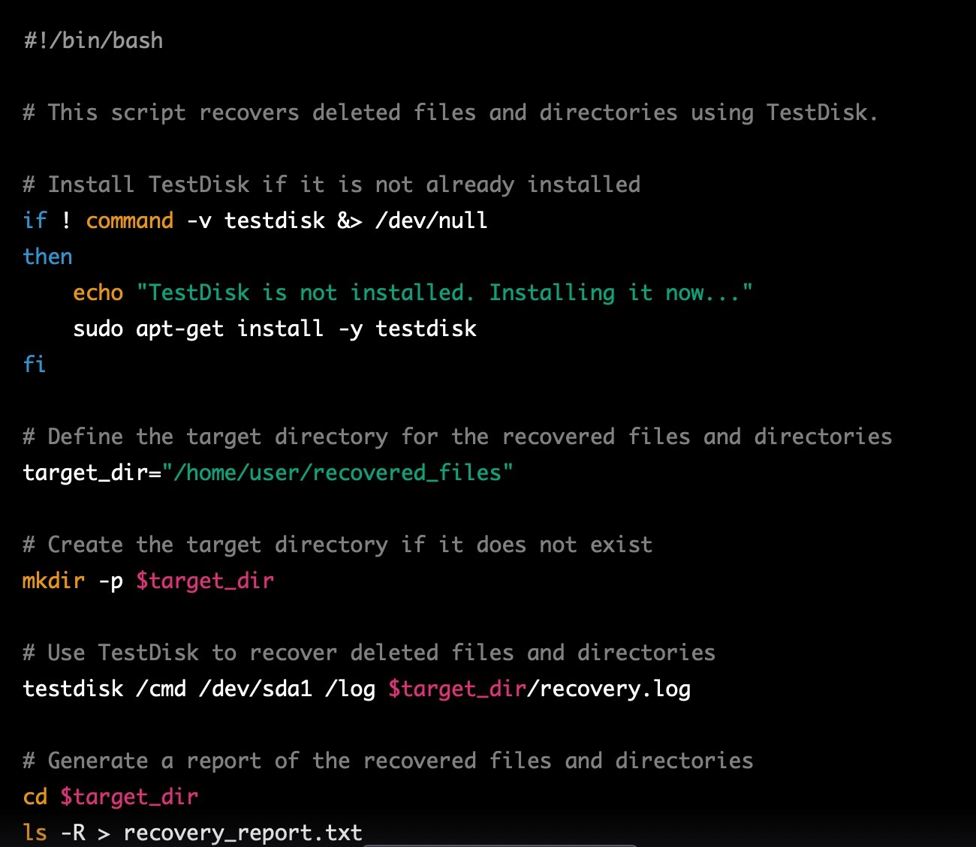

Full screenshot of the script.

LINK:- https://github.com/AkritiSingh03/cse301/upload